Application of Graph Theory to Modeling and Visualization of Epidemiology Data
University of Nebraska at Omaha
Data Science for Health Sciences Concentration, Data Science
DSCI STAT 8950 / Data Science Capstone Project
Professor Lochana Palayangoda, PhD
May 07, 2025

1. Abstract
Epidemiology makes extensive use of geographic data to model and visualize patterns of disease and adverse health determinants (Aiello & Banerjee, 2023; Saha et al., 2023; Tan et al., 2020). These methods have made crucial contributions to understanding relationships between health determinants and outcomes (Shiode, 2012). But traditional methods frequently apply non-spatial models to tabular or GIS-enriched data. Without extensive feature engineering to encode spatial relationships, these methods risk under-exploiting spatial relationships between environmental determinants and population health outcomes. Using data sets drawn from county-level cancer data, EPA Superfund sites and river characteristics, this study constructs a heterogenous graph to investigate the benefits of converting tabular data to node-and-edge representations for use in a spatially aware machine learning model. With nodes consisting of Counties, Superfund sites and Major Rivers, and edges consisting of bi-directional connections between Counties, Superfunds, and Rivers, we show an application of a GraphSAGE model predicting county cancer rates. With minimal data processing or feature tuning, our model achieves validation RMSE of 51.44, an 11.6% improvement over baseline predictions of the standard deviation (58.2). We use ablation trials to quantify relative contributions of features within the superfund and river nodes, demonstrating that spatial characteristics of Superfund sites and size of river drainage basins make major contributions to model predictions. Ablation of other features in Superfund or River nodes reduce validation RMSE by between 6.4 and 24.6, suggesting that epidemiology research may benefit from using node-and-edge representations in a spatially aware model when spatial relationships are of interest.

2. Introduction
Geographic data offers crucial insight into epidemiology research. A classic example of explanatory geographic analysis in epidemiology is John Snow’s 1854 map of cholera casualties. Often considered a foundational example in visualization of epidemiology data, the map plots the number of deaths attributed to cholera against a map of neighborhoods in the Soho district of London, clearly suggesting a connection between the number of casualties and the geographic location of public water pumps (Shiode, 2012).
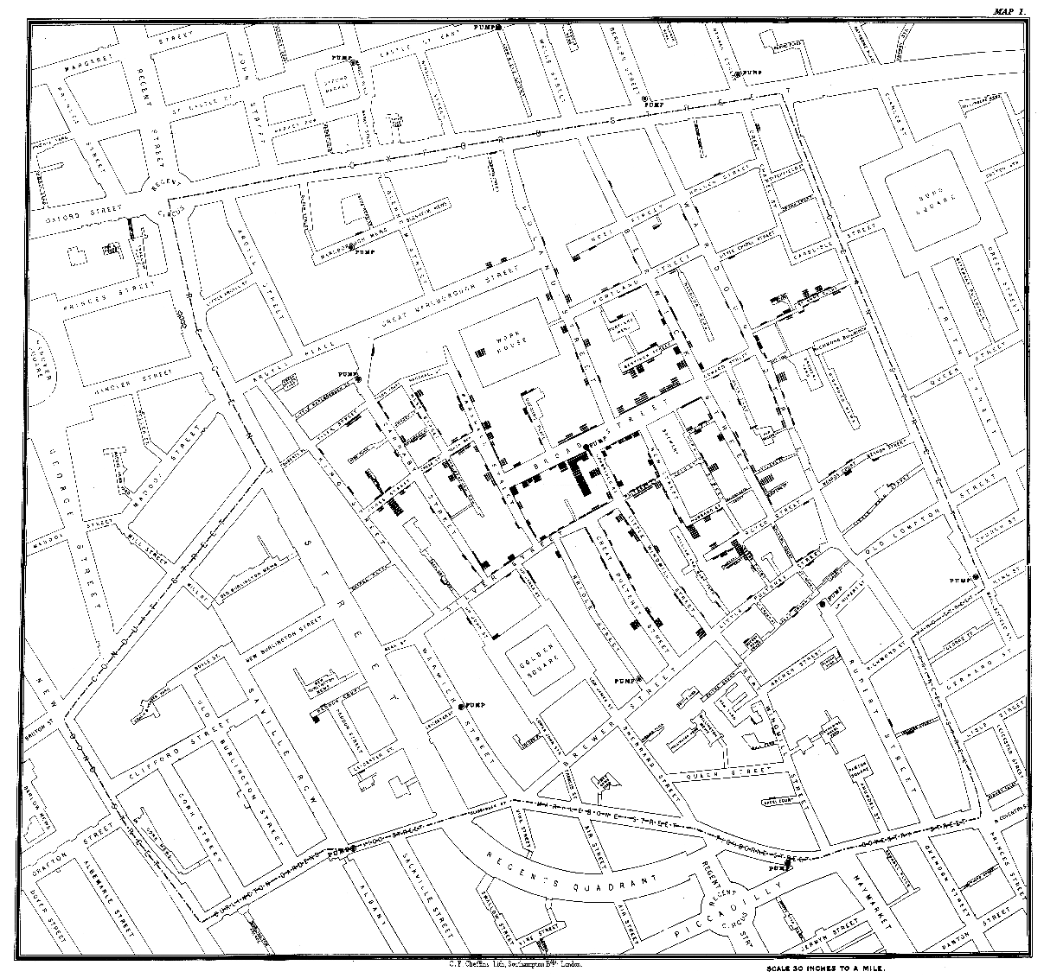
Figure 1. John Snow’s cholera map of 1854, showing cholera case distribution around the Broad Street pump. Reprinted from Wikipedia (https://en.wikipedia.org/wiki/File:Snow-cholera-map-1.jpg).

While the Snow map is instructive, it is a nascent attempt to visualize these types of relationships and is improved relatively easily using modern visualization tools. For example, a heat map of casualty density quickly locates the areas most heavily impacted.

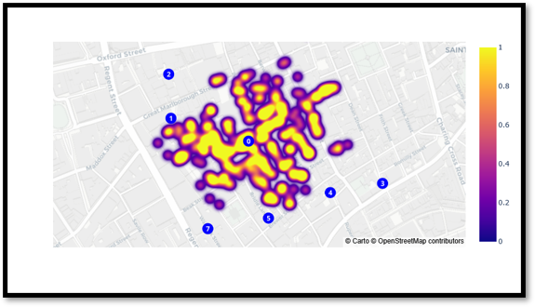
Figure 2. John Snow's Cholera Map data represented in a heat map with casualty concentrations colored from low to high. Map data © OpenStreetMap contributors, licensed under ODbL.
While improved, Figure 2 still lacks an implicit connection between the geographic components of the data and the outcome. Specifically, it does not unambiguously connect the casualties to a specific water pump. Instead, it leaves the story within the data ambiguous, suggesting a relationship between water pumps and casualties without identifying it.

If we convert the data again, this time into a bipartite graph with edges connecting casualties to the nearest public water pump, the pattern is immediately and unambiguously clarified: there is exactly one pump which clearly dominates the geographic connections to fatalities.

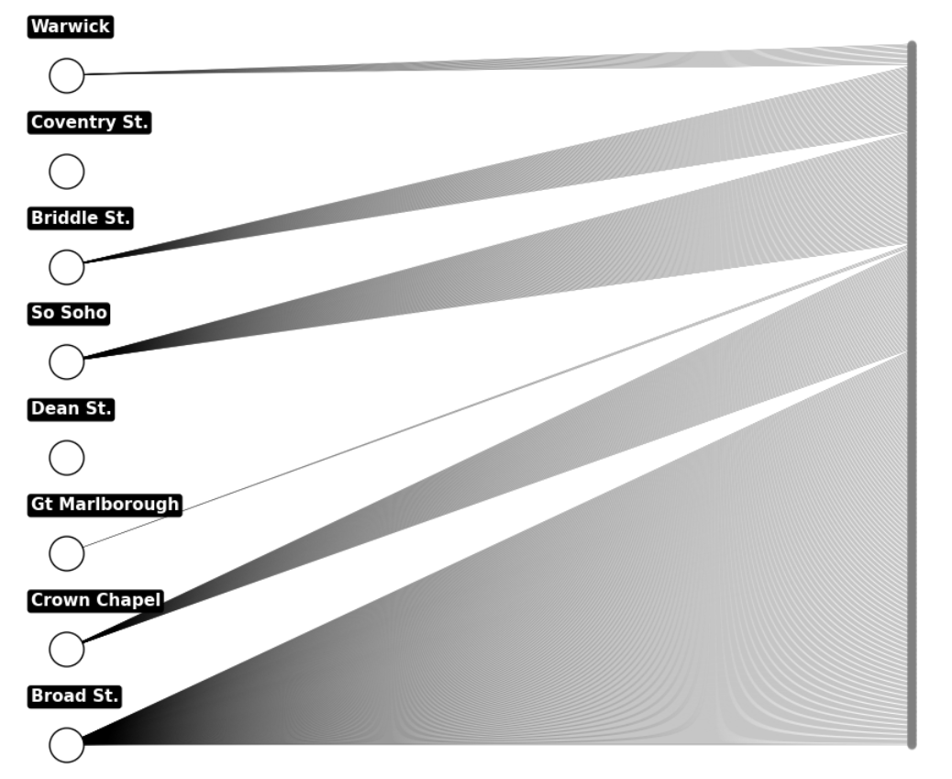
Figure 3. John Snow's Cholera Map data visualized as a bipartite graph of nodes and edges where nodes represent public water pumps and casualties and edges represent the links between casualties and the geographically closest water pump.
This suggests that some epidemiology data contains spatial patterns that offer significant explanatory power. The observation of increased clarity when transformed into node-and-edge format informs the research question in this study: Do spatially aware machine learning models extract meaningful relationships from epidemiology data rendered as a graph of nodes and edges?

The investigation of this question involves certain assumptions. The first assumption is that epidemiology data contains embedded geographic relationships that can be exploited by spatially aware machine learning models. The second assumption is that when using spatially aware machine learning models we benefit from converting data to node-and-edge representations rather than using traditional tabular or GIS-enriched formats.

We investigate our research question and assumptions by obtaining public data sourced from the EPA, NIH, and widely available geographic statistics. All three data sets contain observations with geographic information, facilitating conversion of the observations into nodes containing geographic features, and drawing edges between based on those geographic features. Using this format we construct a heterogeneous graph connecting EPA Superfund sites, Counties in the continental United States, and the continental United States’ ten largest rivers. Counties form the base of our graph structure, and we link counties to the Superfund sites within their borders. Then we link counties to the rivers that intersect or run adjacent to their borders.

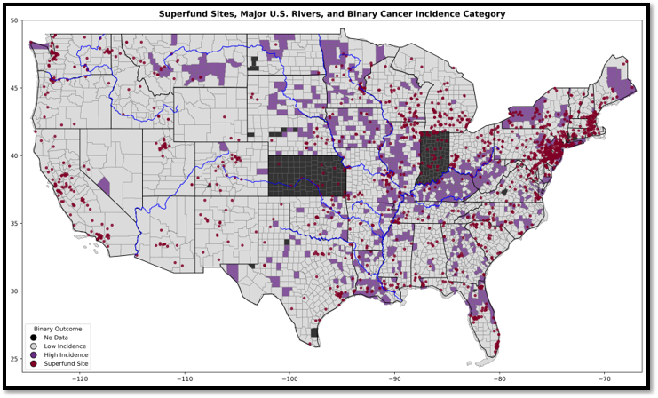
Figure 4. Spatial distribution of Superfund sites, major U.S. rivers, and binary cancer incidence categories across the continental United States.

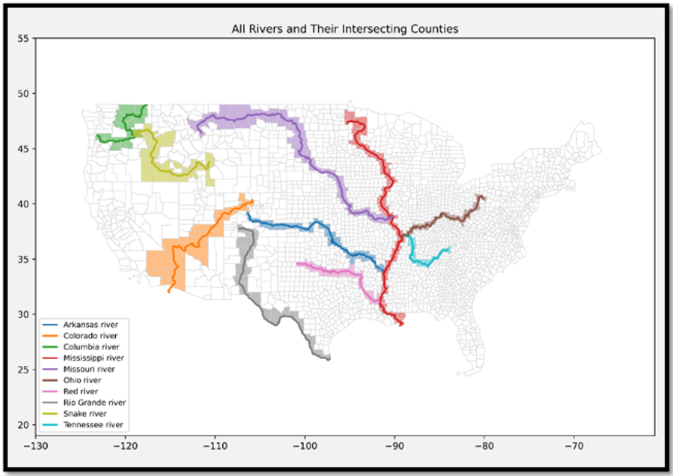
Figure 5. Visualization of county-river adjacencies and intersections for the 10 largest rivers in the continental United States.
County nodes are labeled with the cancer incidence rate (on a per 100,000 basis and adjusted for age) provided within the NIH-sourced county data set (State Cancer Profiles > Incidence Rates Table, n.d.), and cancer incidence rate forms the target for our model’s predictions.

Superfund nodes contain geographic data in the form of longitude and latitude, along with environmental attributes such as a ranking of hazard level, designation of facility type, and the list of contaminants associated with the specific site. Superfund data is sourced from EPA Data and Reports (US EPA, 2015).

River nodes contain a limited set of hydrological data, including drainage basin size, discharge volume, length, and geographic scale ranking, with data provided by publicly available encyclopedia sources (WHERE ARE AMERICA’S TEN MOST POLLUTED RIVERS?, n.d.).

Using this heterogeneous graph structure, we process the datasets, conduct a minimal amount of feature engineering, develop a pipeline for applying a graph neural network model, implement tuning methodology and produce a set of results that suggest there is support for the use of node-and-edge representations of epidemiology data in the exploration of environmental health determinants on health outcomes in localized populations.

3. Literature Review
3.1 Traditional approaches to Spatial Relationships in Epidemiology
Traditionally epidemiology relied on modeling geographic variation in disease patterns using statistical techniques such as conditional autoregressive modeling and spatial error models (Beale et al, 2008, Rezaeian et al, 2007), methods particularly effective in small-area estimations (Simkin et al, 2022). These methods are well tested and quite effective, but they do not natively encode spatial structure, and they perform much less effectively when the model incorporates heterogenous interactions involving multiple types and sources of data, or environmental hazards resulting from indirect exposure or unidentified pathways (Piel et al, 2020, Lee and Sarran, 2014).

3.2 Modeling with GIS-Based Systems
Use of Geographic Information Systems (GIS) is widespread in environmental health modeling. GIS provides public health surveillance systems a variety of tools, such as exposure mapping, clustering and production of statistical overlays (Clarke et al., 1996). GIS are a go-to for epidemiology analysis because they are capable of supporting buffer analyses, spatial joins and layered queries (Oliver et al., 2005). GIS are, however, primarily a descriptive tool. They are not well-suited for native encoding of spatial relationships, and do not enable the dimensional inference unless enriched with additional post-hoc analysis – a serious limiting factor, considering the extent to which research into environmental health determinants are increasingly concerned with the intricate spatial relationships found in large, multiscale datasets drawn from multiple sources (Cui et al., 2022).

3.3 Machine Learning and Environmental Health Determinants
Standard models have proven effective in public health monitoring. Boosted tree models, random forests and neural networks excel in situations featuring nonlinear interactions and highly dimensional data applied to applications including prediction of cancer, disease clustering and environmental hazard exposure (Aiello & Banerjee, 2023, Fayet et al., 2020). But using traditional models in these domains normally requires spatial structure is reduced to flat features through methods such as point-to-point distance encoding, classification into zones or regional scoring (Benavidez et al., 2024). Flattening of spatial data risks obliteration of key patterns necessary to model characteristics like flow exposure or adjacency-mediated events, particularly in epidemiology applications, in which spatial structures have potentially monumental relevance to health outcomes (Keeling & Eames, 2005).

3.4 Environmental Health Determinants and Population-Level Health Outcomes
Superfunds are the site of a variety of environmental contaminants, including carcinogenic or mutagenic agents like heavy metals, volatile organic compounds, polychlorinated biphenyls and pesticides, that are considered long-term health risks even at low levels of exposure (US EPA, 2015). Hazardous sites are linked by proximity measures to a variety of adverse health outcomes, including increased risks of cancer, immune disease and developmental abnormalities (Piel et al., 2020).

3.5 Rivers as Pathways for Environmental Hazard Exposure
Rivers provide a potential vector for the collection and transport of environmental contaminants. Major rivers have the potential to aggregate sediment-bound contaminants, industrial byproducts and agricultural residue throughout massive drainage basins (Besse & Faye, 2021). The collection of contaminants may be cumulative, meaning that riverine counties are exposed to increased risk of contaminants by virtue of being downstream of previously collected sources of contamination from throughout the river’s drainage system. An example of riverine clustering can be found in Teibo et al.’s review of tuberculosis risk, in which clustering along river networks was discovered to be extant and independent of income (Teibo et al., 2023). Direct assessment of downstream effects seems uncommon in the literature, possibly due to the difficulty of modeling the impacts of unidirectional flow. Converting data to node-and-edge graph format is an obvious solution to enable examination of directed flow and transmission dynamics in a hydrologic network (Besse & Faye, 2021).

3.6 Graph Neural Networks and Spatially Aware Machine Learning
Among the design features of Graph Neural Networks (GNNs) are abilities related to modeling spatial structures. GNNs are designed to explore how connections moderate interactions between entities (Hamilton et al., 2018). GNNs thrive when applied to data consisting of explicit network topologies, as in social networks or citation webs, and their utility is increasingly recognized in applications featuring geospatial, spatiotemporal, sociospatial aspects (Shchur et al., 2019, Anaadumba et al., 2025). Recent proposals and demonstrations have exposed potentially interesting GNN applications, such as application to noisy geospatial data (Hasegawa et al., 2024) and modeling epidemic dynamics through explicit definition of spatial structure via partitions (Bonaccorsi et al., 2015).

4. Data Description
This study constructs a heterogenous graph of three node types with edges connecting the nodes based on simple geographic relationships, as shown in Figure 5. Superfunds connect to the counties in whose borders they reside and rivers connect to counties whose borders the river centerline intersects with or runs adjacent to.

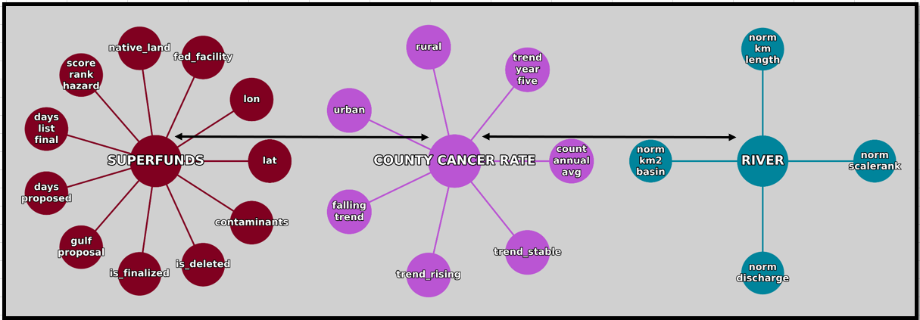
Figure 6. Structure of the heterogeneous graph object.
The cancer dataset was taken from the National Institute of Health (NIH) State Cancer Profiles: Incidence Rate Report for United States by County (2017-2021). This data set collects age-adjusted cancer incidence rates for county level populations and includes all cancer types and sites, and all ages, races and sexes. Because the study focuses on the continental United States, some counties were excluded from the data set. These include Alaska, Hawaii or U.S. territories, Washington D.C., and the U.S. territories. Additionally, Indiana and Kansas were excluded because those counties were not represented in the data set obtained from the NIH. Additionally, due to widespread variation between neighboring states, and the extent of variation seen between individual counties within states, it was determined there was no acceptable basis for imputing values for missing counties in a large contiguous area. As a result, those counties were dropped from the data set. Features in the data set included the rural or urban designation, the annual average new cases, and the five-year trend of cases.

The Superfund dataset was sourced from the Environmental Protection Agency (EPA), specifically from the EPA Superfund Data and Reports, FOIA-015 Full Report of all Final, Proposed, and Deleted National Priorities List (NPL) sites. The sites used were restricted at the time of pre-processing to those within the continental United States, while in the edge-pairing step of graph construction, the edges drawn required both a Superfund site and a containing county for an edge to be drawn. Features in this data set included longitude and latitude, the Hazard Ranking Score assigned to the site, the category of facility assigned to the site, whether the site was a federal facility or located on Native American land, the specific contaminants the site is associated with, and the dates on which the site was proposed for listing, finalized for listing, and/or deleted. Note that some sites were discovered to have been proposed for listing but had not had the listing finalized at the time of this research.

The Rivers dataset was sourced from the Natural Earth shapefile resources (says, n.d.), and filtered to retain the ten largest rivers in the continental United States. This dataset includes spatial data, including the river centerlines, and additional metadata, including river length, drainage area and discharge volume, were manually added after verification via publicly available encyclopedia sources.

These data sets were processed to filter observations including NA values in critical columns, such as cancer incidence rate in the county data set, or hazard rank score in the Superfund data set. Additional processing included assigning FIPS codes to Superfunds based on their latitude and longitude. Union County, Florida, whose cancer incidence of 1248.4 is 554.9 higher than the next nearest county, and whose cancer rate is inflated by the combination of low population with a penal facility with a medical unit to which incarcerated individuals with cancer diagnoses are assigned, was removed from the county dataset as an irregular and distorting outlier (U.S. Census Bureau QuickFacts, n.d., “Reception and Medical Center,” 2024, “Reception and Medical Center Work Camp,” n.d).

5. Exploratory Data Analysis
Exploratory data analysis explored the geographic texture of cancer incidence and Superfund site distribution. After data cleaning and removal of the Union County, FL outlier, the county data set contained 2,932 observations. The Superfund data set contained 1,606 observations, and the Rivers data set contained 10 observations.

Cancer Incidence
Cancer rates ranged from 182.3 to 693.5 with a slightly left-skewed distribution, with skewness approximately -.57. Approximately 80% of counties have a cancer rate between 400 and 540.
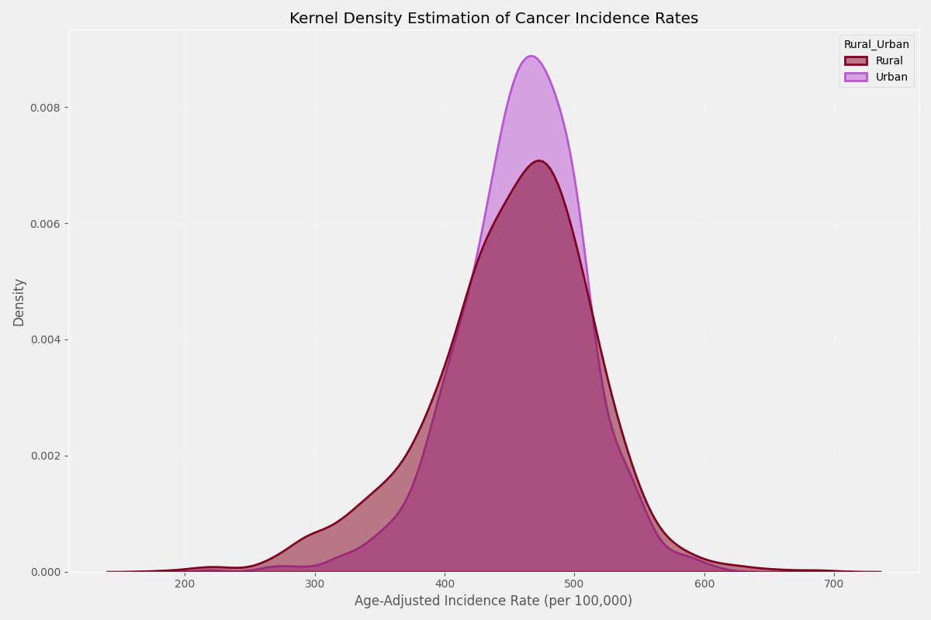
Figure 7. Kernel Density Plot of the cancer incidence rates for Rural and Urban counties.
Cancer rates were visualized through geographic mapping with categorical coloring. A range of k values from 2 through 21 were considered in the exploratory phase. It quickly became apparent that human-level comprehension of color maps became distressingly complex as k values increased as the number of colors used reduced differentiation between each shade as k was increased.

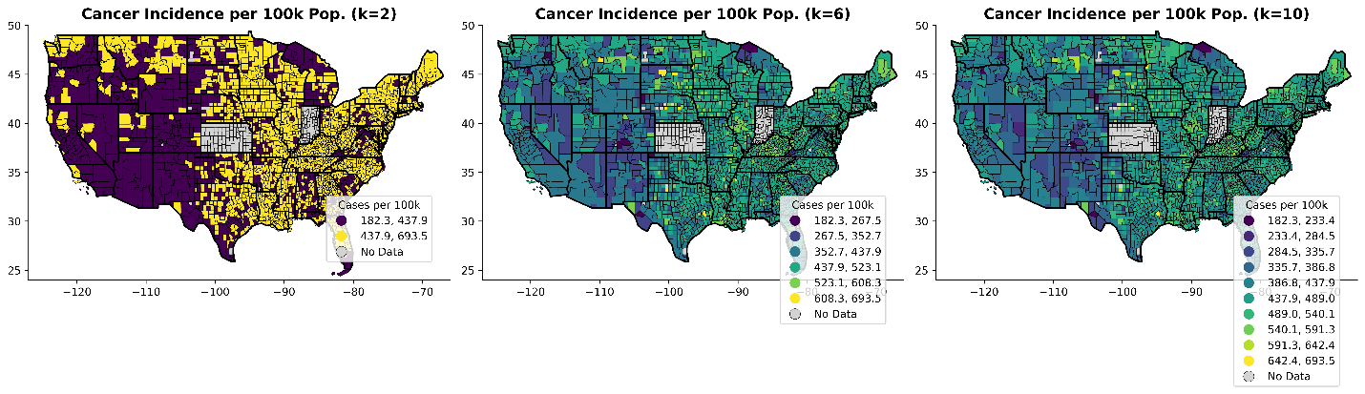
Figure 8. Comparison of county-by-county coloring of cancer rate at different k values.
As a result, categorizing county cancer incidence in two or three bins proved preferable. Review of the range of the cancer incidence data showed approximately 80% of counties had cancer incidence rates between 200 and 500 and the decision to classify counties in two bins, one holding 2,647 low-and-medium incidence counties with between 200 and 500 cancer incidence rate, and the other holding 585 counties with high cancer incidence rate.

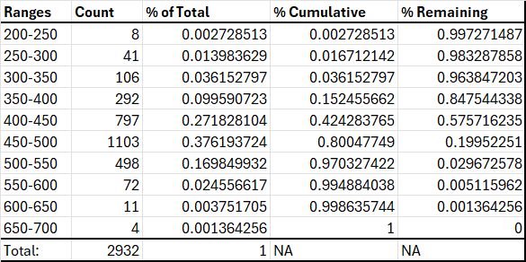
Table 1. Detailed breakdown of the range of the target variable, county cancer rate.
The result was a highly interpretable map of high-incidence counties upon which several clusters of high cancer rate counties were observable. Clusters of high cancer rates were present in a variety of geographic areas, including New England, the upper Midwest, the Kentucky and West Virginia area, and the central southern corridor running along the Mississippi River from St. Louis to the Gulf of Mexico.

Superfund Sites
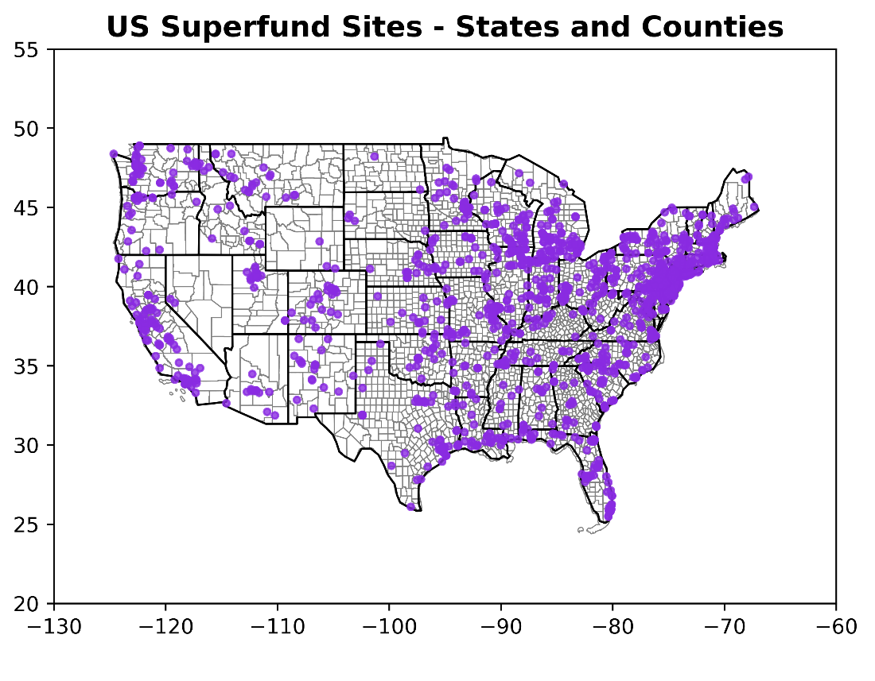
Figure 9. Locations of Superfund sites plotted against a state-and-county borders map of the continental United States.
Interestingly, plotting Superfund sites alongside cancer incidence did not tell a compelling, cohesive story. While there were clusters of Superfund sites in close relation to high cancer incidence counties in places like Florida, Louisiana, Minnesota, Montana and the central southern states, there were many geographic areas in which there were dense clusters of Superfund sites with few or no high-incidence counties in close relation. For examples, see central California, Michigan, Wisconsin, Massachusetts, Vermont, New Hampshire and Colorado. This presented an interesting avenue of inquiry considering that Superfund sites are known to be potential sources by which powerful carcinogenic compounds can enter the environment; the difference between the expected pattern of co-expression and the actual pattern was judged to invite further investigation.

Major Rivers
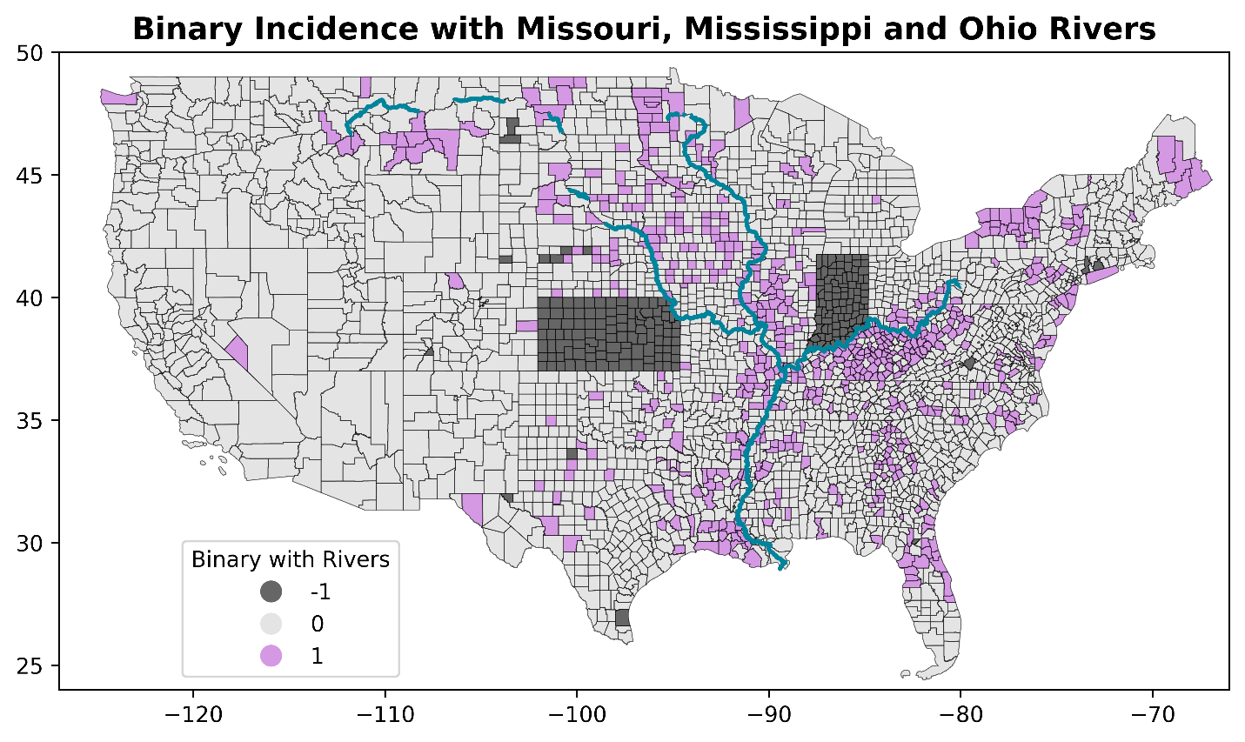
Figure 10. County cancer rates visualized on a state-and-county borders map of the continental United States with counties categorized into high incidence (purple) and low incidence (gray), with black indicating no data. The centerlines of three major rivers are traced on the map for comparison with the spatial distribution of high cancer rate counties.
Figure 10 visualizes the high cancer incidence counties with an exploratory addition of three major river (Missouri, Mississippi and Ohio rivers) centerlines traced in blue. Of note is what seems like a pattern of high cancer incidence near these three rivers. The Missouri passes close to the high incidence counties in Montana and South Dakota, while the Mississippi starts in a cluster of high incidence counties in Minnesota. The Missouri and Mississippi rivers make up western and eastern borders of Iowa, respectively, and Iowa contains a high proportion of high incidence counties relative to its midwestern neighbors (other than Illinois). The Ohio River forms the northern border of one of the densest clusters of high cancer incidence counties in the country along the southern border of Ohio, Indiana and Illinois and the northern borders of West Virginia and Kentucky. All three rivers meet near the southeastern edge of Missouri and follow a path south to the Gulf of Mexico, along a string of high cancer incidence counties before finishing in a geographic region sometimes referred to in pop science media as ‘Cancer Alley’ (US, 2024). It’s not immediately apparent whether this pattern is statistically significant or a result of confirmation bias and pareidolia, making the association an attractive target for analysis.

This EDA exposed interesting avenues of inquiry, and formed the basis for deciding how the graphs should be constructed later in the modeling pipeline, particularly in the area of river centerline adjacency/intersection; it also informed the encoding of Superfund nodes by suggesting that, in light of the lack of distinct correlation noted in the geographic mapping, it should be considered that not every Superfund site contributes to population level health outcomes, or contributes in the same way, or in the same geographic patterns.

6. Methodology
This project followed a standard modeling structure to test a graph neural network (GNN) on predicting county-level cancer incidence rate using a combination of county level data, superfund data and hydrological data containing a mixture of environmental and non-environmental features, with the goal of exploring how the GNN might facilitate exploration of the impact of environmental features.

Step 01 – Collect and Pre-Process Data
Cancer data at the county level was sourced from the NIH, while Superfund data was obtained from the EPA and river shapefiles from Natural Earth. Data sets were filtered and cleaned, then Exploratory Data Analysis (EDA) was performed. After exploration, the data was prepared for modeling by dropping irrelevant features then converting non-numeric features to numeric via encoding. It is important to note at this step that effective use of GraphSAGE requires consistent control of the runtime to enforce compatibility between the environment and libraries such as PyTorch Geometric and NumPy. Consistent with these requirements, all categorical features must be converted to numeric. While this is not unusual in modeling, the use of tensors to store node feature matrix data will require that all numeric data is eventually cast explicitly to float32 format.

Step 02 – Constructing Nodes and Instantiating the Heterogenous Graph
PyTorch Geometric was used to construct a HeteroData object (this object is the heterogeneous graph) consisting of three node types: County, Superfund and River. A feature matrix was applied to each node type consisting of features drawn from its respective data set. Type distinction was preserved by using spatial joins to facilitate the drawing of edges.

Step 03 – Construct the Edges
Edges were drawn to represent spatial relationships. County to Superfund edges linked Superfunds to the counties in which they reside, while County to River edges linked counties to the rivers that intersect or run adjacent to their county borders. These were directed edges, meaning that travel through these edges was able to occur in only one direction. Since bidirectional message passing was desired, for example, as in rivers both contributing to county exposure and possibly receiving additional exposure risk from superfunds located in the counties, we applied an edge flipping function to create a reciprocal edge.

Step 04 – Chemical Contaminant Encoding
Superfund site contaminants were initially provided in long data format. During preprocessing steps, the data was converted to wide format and the contaminant lists for each site collected into a list of strings. This list of strings was converted to a binary feature matrix, causing an explosion in dimensionality that impacted model run time and accuracy. As a result the decision was made to replace the chemical contaminant binary feature matrix by grouping the contaminants into six classes based on their Chemical Abstracts Service (CAS) number. The six classes:
- Polycyclic Aromatic Hydrocarbons
- Polychlorinated Biphenyls
- Heavy Metals
- Volatile Organic Compounds
- Pesticides
- Other Chemicals

Step 05 – Contaminant Weighting
The carcinogenic potential of each chemical class varies. To accommodate these differences, each of the contaminant groups were weighted using coefficients. The weights chosen were:
- Polycyclic Aromatic Hydrocarbons: .95
- Polychlorinated Biphenyls: .85
- Heavy Metals: .80
- Volatile Organic Compounds: .70
- Pesticides: .65
- Other Chemicals: .30
We computed a weighted contaminant risk score by site.

Step 06 – Model Architecture
We defined an nn.Module using GraphSAGE layers (SAGEConv) per node and edge type. Edge specific message passing layers were applied and final fused embeddings were used to provide a regression estimate of county level cancer rates.

Step 07 – Training and Evaluation
Data was split by FIPS code to avoid spatial leakage. MSE was used as the primary loss metric and results were presented via RMSE for interpretability. Models were trained using early stopping and tested over a variety of epoch values. Trials tended to show the model benefitting from relatively high numbers of epochs, with the gains being modest and incremental, at the expense of massively increased runtimes.

Step 08 – Hyperparameter Tuning
A hyperparameter optimization process was conducted using Optuna to conduct consecutive iterative studies with increasingly narrow parameter spaces. The studies were conducted with a range of between 200 and 500 trials. Optuna tended to find a near-optimal configuration within the first 100 trials and then make a low number of modest, incremental improvements, only after extended processing time, sometimes only after 100 or more trials. For this reason, the final Optuna study, using the narrowed parameter space, was conducted with 200 trials. The search space focused on the following parameters (final values included):
- Number of layers: 3
- Hidden dimensions: 384
- Aggregation Method: mean
- Learning Rate: 3.2e-3 to 4.6e-3, log=True
- Weight Decay: 4e-5 to 6e-5, log=True
- Dropout: .16 - .18
- Normalization: batch normalization false
- Accumulation Steps: 10, 12
The model appeared particularly sensitive to the number of layers, hidden dimensions, learning rate and dropout.

Step 09 – Final Model Training
The best hyperparameter configuration was tested by extracting the ideal hyperparameters and applying them to the final model after each Optuna study was completed. The model was evaluated on held-out counties.

Step 10 – Testing Feature Importance
To test feature importance ablation functions were used to systematically remove pre-defined features and feature groups: County features, River features, Superfund spatial and temporal features and Superfund chemical features. The feature importance was quantified via the difference between the RMSE of the full model and the RMSE of the model with the selected features held out.

7. Results and Evaluation
After finalizing the model, it was optimized using a 200-trial Optuna study. Multiple rounds of tuning were performed with the goal of narrowing the parameter space through iterative trials, during which early stopping was used to minimize the number of fruitless epochs computed. The parameters Hidden Channels, Learning Rate and Dropout were found to be particularly influential in the tuning process, and eventually a validation RMSE of 50.7 was achieved. Using the parameters from the best trial, the final model was constructed, and a 2,000-epoch trial was launched. An early stopping parameter was used to ensure the trial was able to fully explore the data while limiting the number of consecutive epochs permitted with no or trivial gains in the evaluation metric. The Optuna Optimization History plot shows significant improvement taking place quickly over the first 20 to 25 trials, with a significant plateau until the final improvement at trial ~120.
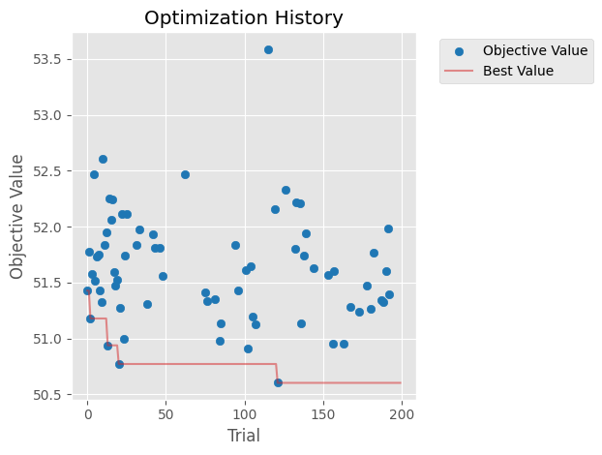
Figure 11. Optuna Study optimization history for the final study with narrowed parameter space, showing convergence through iterative parameter space tightening. Compared to earlier studies where RMSE varied from mid-50s to more than 100, the 200 trial final study has a significantly reduced range of 3.
Using the parameters found in the final Optuna study, the final model achieved a validation RMSE of 51.44 and an R2 score of .22 on a target with a mean of 454.4 and a standard deviation of 58.2. This shows the model outperforms a baseline using the mean as a predicted value by a meaningful margin, and plots comparing training and validation RMSE over 1500 epochs show minimal evidence of overfitting.

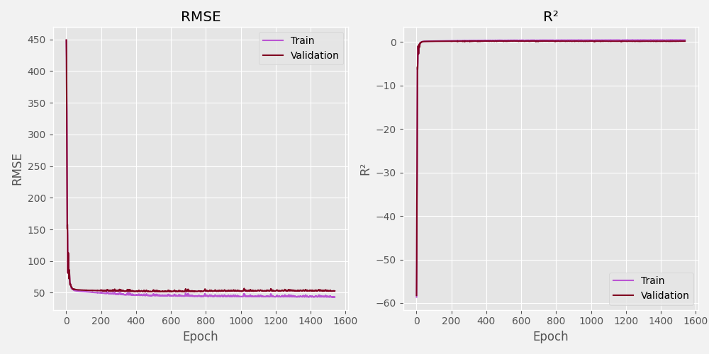
Figure 12.Comparison of the training and validation RMSE and R2 for the final model.
Ablation studies uncovered instructive patterns regarding feature importance. In the final model the county features were overall the most dominant group, with 5-year trend the most influential feature by a significant margin; its removal resulted in an 87-point increase in RMSE. Rural and Urban features were second and third, indicating there is meaningful signal in the distinction between rural and urban counties.

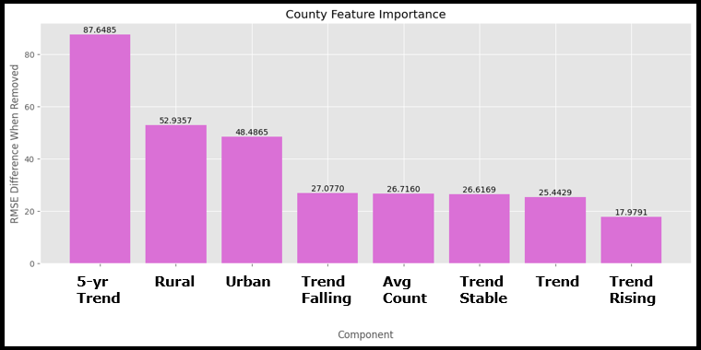
Figure 13. Feature importance of County features tested via ablation trials.
Interestingly, the geographic features of the latitude and longitude from the Superfund nodes were the fourth and fifth most important features, producing 28.9 and 27.3 increase in RMSE, respectively, when removed. This provides support for the importance of spatial awareness in modeling the impact of environmental hazards.

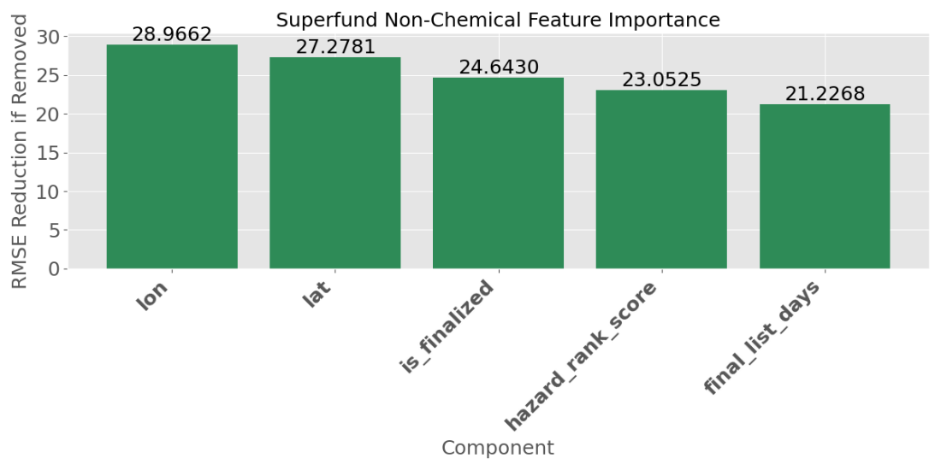
Figure 14. Feature importance of Superfund spatial and temporal features tested via ablation trials.
Contaminant types also made significant contributions, with PCBs, heavy metals, Volatile Organic Compounds and pesticides all representing an increase of 17 to 19.3 RMSE if removed.

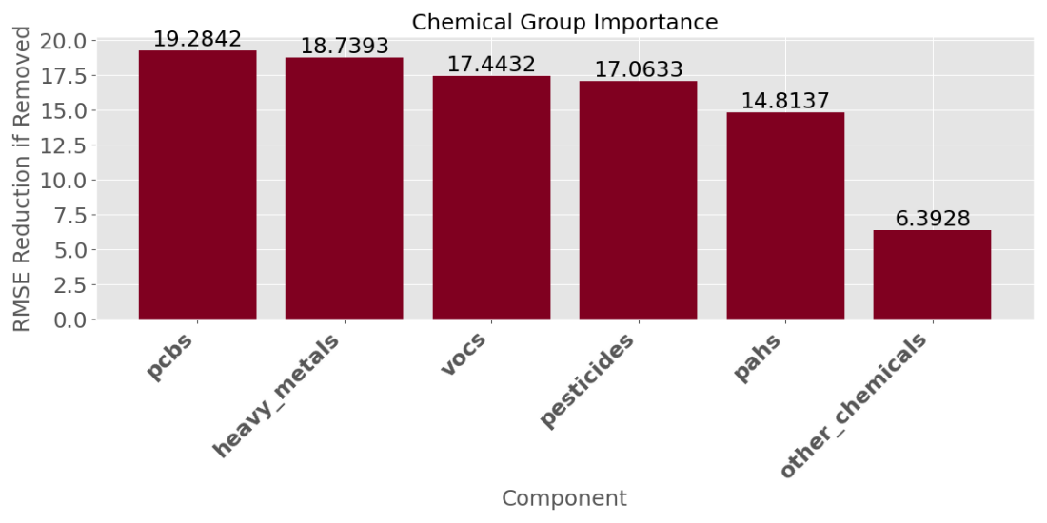
Figure 15. Feature importance of Superfund chemical category features tested via ablation trials.
One of the most interesting findings is that the Rivers nodes, which is relatively naïve in that they contain only four very simple features, provided meaningful signal. The size of the drainage basin was the 10nth most important of the 23 features tested, which supports the supposition that rivers may serve to collect environmental contamination from a wide geographic area, collecting the exposure risk and potentially providing a pathway through which the risk might move.

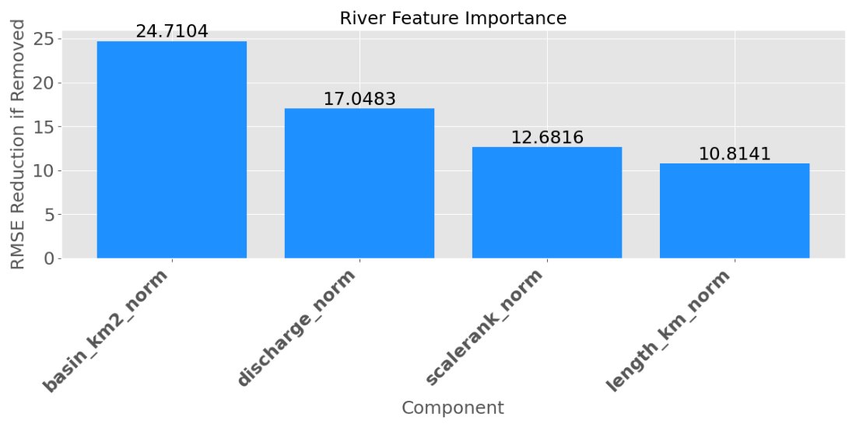
Figure 16. Feature importance of River characteristic features tested via ablation trials.
This model’s performance, particularly the R2 score of .22, might seem modest in the context of typical machine learning tasks in which R2 is typically much higher. It is, however, consistent with the expected range for results in environmental epidemiology, a domain in which published work features R2 scores that vary significantly, with a range of between .02 and .66 found for various cancer types in some recent publications (Casaes Teixeira et al., 2023, Gu et al., 2023).

8. Discussion
While the GraphSAGE model demonstrated performance within the expected range for spatial epidemiology modeling, it must be conceded that if the goal is accurately predicting cancer incidence, standard, tabular models are much more accurate, achieving RMSEs from 1.69 to 3.25 while using just the features contained within the cancer data set.

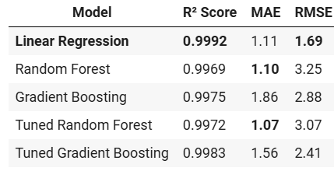
Table 2. Comparison of evaluation metrics for a selection of standard models using only the county dataset to predict county-level cancer rates. Data provided by Jeswanth Reddy Dwaram as part of the Team F Mid-Semester Progress Update.
However, it must be also be noted that these models are predicting the target based on analysis of the target’s derivative data. They do not speak to the contributions of environmental hazards to local population health outcomes. Nor do they contribute to the understanding of spatial relationships, or the geographic influences.

This distinction is crucial for understanding the purpose of the graph-based approach that is the focus of this study. The node-and-edge format, particularly when used in a GraphSAGE model featuring neighborhood aggregation (Hamilton et al., 2018), allows the spatial structures to be evaluated without the necessity of extensive feature engineering to encode proximities and adjacency matrices, or other numeric abstractions of spatial relationships. Instead, the spatial context is encoded simply by defining the node types and assigning spatially meaningful edges, such as connected to, resides within, flows through, intersects with. Via neighborhood aggregation, this allows the model to learn both the local county data, and the structure of the environmental neighborhood.

The relatively modest R2 and the comparatively high RMSE are expected given the model is attempting to pull meaning from spatial epidemiology data and environmental influences into a prediction on cancer rates, which are influenced by a vast wealth of social, demographic, genetic and behavioral traits that, although in many cases more direct in their impacts, are not assessed or included in this model. But the results remain interesting when considered in the context of spatial epidemiology, in which the RMSE of our model is a significant improvement over a naïve baseline and the R2 is consistent with R2 values in recently published work (Casaes Teixeira et al., 2023, Gu et al., 2023). Additionally, the most interesting development of the study is the ablation study, which indicates the Superfund and River nodes have a significant influence on the accuracy of predictions, particularly in the case of Superfund latitude and longitude, and River drainage basin area and discharge volume.

As a result, the proposed use of the model is not to increase the accuracy of predicting cancer rate over the already accurate standard models, but rather to demonstrate a route for including geographic factors and environmental health hazards, and to investigate their role in shaping the health outcomes of local populations.

9. Conclusion
This research studied the feasibility of converting tabular data to a node-and-edge representation for use in a graph-based neural network featuring a network aggregation style to predict county level cancer rates while incorporating spatial and environmental data.

The model achieved an RMSE of 51.44 against a standard deviation of 58.2, representing an improvement over the baseline mean prediction. The R2 was .22, which is consistent with and falls within the range of .09 and .3 that is common for publications in the domain of spatial epidemiology.

While the RMSE was significantly higher than standard models trained solely on data held within the cancer data set, the GNN-based node-and-edge model is not proposed as the most ideal model for accurately predicting county level cancer rates. Instead, the utility of the GNN using graph-based data lies in the ability to easily integrate abstract spatial relationships through the technique of neighborhood aggregation. This ability was demonstrated through the inclusion of Superfund sites and River nodes into a structure that allows testing hypotheses about environmental influences through techniques such as feature ablation.

Our study suggests the value of the GNN model may be less than that of the standard models when the application is focused on accurately predicting outcomes such as county cancer rate. But the study also suggests the GNN has utility in a domain the tabular models either can’t function in or can’t function easily – the utility of facilitating exploration of the role spatial relationships and environmental hazards play in influencing those local, population level outcomes.

In addition, it is likely that more sophisticated and accurate models are possible should the authors continue developing experience and expertise in using GNN models. Directions of future testing that may hold promise in enhancing the model include the addition of more types of connections, refining edge definitions, or incorporating additional environmental exposure data. For example, the EPA publishes the Map of Radon Zones, categorizing counties based on potential indoor radon levels. As radon is the second leading cause of lung cancer in the United States (Does Radon Cause Cancer?, n.d.), it may be safe to predict the addition of radon categorization to the model, will result in more precise predictions and more relevant analysis of geographic influences. It will also be instructive to test adding radon via two methods: creating a new set of ‘Radon Nodes’ to connect to the county nodes, compared to adding the radon data by merging directly with the county nodes themselves, permitting comparison of the impact when included as a feature directly against when the feature is isolated as a node for inclusion in the neighbor aggregation function.

10. References

Aiello, L., & Banerjee, S. (2023). Detecting Spatial Health Disparities Using Disease Maps (No. arXiv:2309.02086). arXiv. https://doi.org/10.48550/arXiv.2309.02086
Bath, P. A., Craigs, C., Maheswaran, R., Raymond, J., & Willett, P. (2005). Use of Graph Theory to Identify Patterns of Deprivation and High Morbidity and Mortality in Public Health Data Sets. Journal of the American Medical Informatics Association, 12(6), 630–641. https://doi.org/10.1197/jamia.M1714
Beale, L., Abellan, J. J., Hodgson, S., & Jarup, L. (2008). Methodologic Issues and Approaches to Spatial Epidemiology. Environmental Health Perspectives, 116(8), 1105–1110. https://doi.org/10.1289/ehp.10816
Benavidez, G. A., Zahnd, W. E., Hung, P., & Eberth, J. M. (2024). Chronic Disease Prevalence in the US: Sociodemographic and Geographic Variations by Zip Code Tabulation Area. Preventing Chronic Disease, 21, 230267. https://doi.org/10.5888/pcd21.230267
Besse, C., & Faye, G. (2021). Dynamics of epidemic spreading on connected graphs. Journal of Mathematical Biology, 82(6), 52. https://doi.org/10.1007/s00285-021-01602-5
Bonaccorsi, S., Ottaviano, S., Mugnolo, D., & Pellegrini, F. D. (2015). Epidemic Outbreaks in Networks with Equitable or Almost-Equitable Partitions. SIAM Journal on Applied Mathematics, 75(6), 2421–2443. https://doi.org/10.1137/140995829
Casaes Teixeira, B., Toporcov, T. N., Chiaravalloti-Neto, F., & Chiavegatto Filho, A. D. P. (2023). Spatial Clusters of Cancer Mortality in Brazil: A Machine Learning Modeling Approach. International Journal of Public Health, 68, 1604789. https://doi.org/10.3389/ijph.2023.1604789
Clarke, K. C., McLafferty, S. L., & Tempalski, B. J. (1996). On Epidemiology and Geographic Information Systems: A Review and Discussion of Future Directions. Emerging Infectious Diseases, 2(2), 85–92. https://doi.org/10.3201/eid0202.960202
Corrections, F. D. of. (n.d.). Reception and Medical Center / Institutions List / Institutions— Florida Department of Corrections. Retrieved February 18, 2025, from https://www.fdc.myflorida.com/institutions/list-of-major-institutions/209
Cui, Y., Eccles, K. M., Kwok, R. K., Joubert, B. R., Messier, K. P., & Balshaw, D. M. (2022). Integrating Multiscale Geospatial Environmental Data into Large Population Health Studies: Challenges and Opportunities. Toxics, 10(7), 403. https://doi.org/10.3390/toxics10070403
Does Radon Cause Cancer? (n.d.). Retrieved May 6, 2025, from https://www.cancer.org/cancer/risk-prevention/radiation-exposure/radon.html
Fayet, Y., Praud, D., Fervers, B., Ray-Coquard, I., Blay, J.-Y., Ducimetiere, F., Fagherazzi, G., & Faure, E. (2020). Beyond the map: Evidencing the spatial dimension of health inequalities. International Journal of Health Geographics, 19(1), 46. https://doi.org/10.1186/s12942-020-00242-0
Geopandas developers. (2023). geopandas: Python tools for geographic data. Retrieved from https://geopandas.org/
Google Colab. (2023). Google Colaboratory. Retrieved from https://colab.research.google.com/
Gu, W., Xue, F., Han, W., Wang, Z., Zhao, J., Zhang, L., Yang, C., & Jiang, J. (2023a). Assessment of the spatial association between multiple pollutants of surface water and digestive cancer incidence in China: A novel application of spatial machine learning. Ecological Indicators, 154, 110897. https://doi.org/10.1016/j.ecolind.2023.110897
Gu, W., Xue, F., Han, W., Wang, Z., Zhao, J., Zhang, L., Yang, C., & Jiang, J. (2023b). Assessment of the spatial association between multiple pollutants of surface water and digestive cancer incidence in China: A novel application of spatial machine learning. Ecological Indicators, 154, 110897. https://doi.org/10.1016/j.ecolind.2023.110897
Hamilton, W. L., Ying, R., & Leskovec, J. (2018). Inductive Representation Learning on Large Graphs (No. arXiv:1706.02216). arXiv. https://doi.org/10.48550/arXiv.1706.02216
Harris, C. R., Millman, K. J., van der Walt, S. J., Gommers, R., Virtanen, P., Cournapeau, D., ... & Oliphant, T. E. (2020). Array programming with NumPy. Nature, 585(7825), 357-362. https://doi.org/10.1038/s41586-020-2649-2
Hasegawa, T., Yun, S., Liu, X., Phua, Y. J., & Murata, T. (2024). DEGNN: Dual Experts Graph Neural Network Handling Both Edge and Node Feature Noise (No. arXiv:2404.09207). arXiv. https://doi.org/10.48550/arXiv.2404.09207
Hunter, J. D. (2007). Matplotlib: A 2D graphics environment. Computing in Science & Engineering, 9(3), 90-95. https://doi.org/10.1109/MCSE.2007.55
Keeling, M. J., & Eames, K. T. D. (2005). Networks and epidemic models. Journal of The Royal Society Interface, 2(4), 295–307. https://doi.org/10.1098/rsif.2005.0051
Lee, D., & Sarran, C. (2014). Controlling for unmeasured confounding and spatial misalignment in long-term air pollution and health studies (No. arXiv:1412.4479). arXiv. https://doi.org/10.48550/arXiv.1412.4479
McKinney, W. (2010). Data structures for statistical computing in Python. Proceedings of the 9th Python in Science Conference, 51-56. https://doi.org/10.25080/Majora-92bf1922-00a
Oliver, M. N., Matthews, K. A., Siadaty, M., Hauck, F. R., & Pickle, L. W. (2005). Geographic bias related to geocoding in epidemiologic studies. International Journal of Health Geographics, 4(1), 29. https://doi.org/10.1186/1476-072X-4-29
Paszke, A., Gross, S., Massa, F., Lerer, A., Bradbury, J., Chanan, G., ... & Chintala, S. (2019). PyTorch: An imperative style, high-performance deep learning library. Advances in Neural Information Processing Systems, 32, 8024-8035. Retrieved from https://pytorch.org/
Pedregosa, F., Varoquaux, G., Gramfort, A., Michel, V., Thirion, B., Grisel, O., ... & Duchesnay, É. (2011). Scikit-learn: Machine learning in Python. Journal of Machine Learning Research, 12, 2825-2830. Retrieved from https://scikit-learn.org/
Piel, F. B., Fecht, D., Hodgson, S., Blangiardo, M., Toledano, M., Hansell, A. L., & Elliott, P. (2020). Small-area methods for investigation of environment and health. International Journal of Epidemiology, 49(2), 686–699. https://doi.org/10.1093/ije/dyaa006
Reception and Medical Center. (2024). In Wikipedia. https://en.wikipedia.org/w/index.php?title=Reception_and_Medical_Center&oldid=125 9064021
Reception and Medical Center Work Camp. (n.d.). Floridaprisonroster.Org. Retrieved February 18, 2025, from https://floridaprisonroster.org/florida/state/reception-and-medical- center-work-camp/
Rezaeian, M., Dunn, G., St Leger, S., & Appleby, L. (2007). Geographical epidemiology, spatial analysis and geographical information systems: A multidisciplinary glossary. Journal of Epidemiology & Community Health, 61(2), 98–102. https://doi.org/10.1136/jech.2005.043117
Saha, A., Ghorbani, M., Suleimenova, D., Anagnostou, A., & Groen, D. (2023). Impact of geography on the importance of parameters in infectious disease models (No. arXiv:2310.02449). arXiv. https://doi.org/10.48550/arXiv.2310.02449
Shapely developers. (2023). Shapely: Manipulation and analysis of geometric objects. Retrieved from https://shapely.readthedocs.io/
Shchur, O., Mumme, M., Bojchevski, A., & Günnemann, S. (2019). Pitfalls of Graph Neural Network Evaluation (No. arXiv:1811.05868). arXiv. https://doi.org/10.48550/arXiv.1811.05868
Shiode, S. (2012). Revisiting John Snow’s map: Network-based spatial demarcation of cholera area. International Journal of Geographical Information Science, 26(1), 133–150. https://doi.org/10.1080/13658816.2011.577433
Simkin, J., Dummer, T. J. B., Erickson, A. C., Otterstatter, M. C., Woods, R. R., & Ogilvie, G. (2022). Small area disease mapping of cancer incidence in British Columbia using Bayesian spatial models and the smallareamapp R Package. Frontiers in Oncology, 12. https://doi.org/10.3389/fonc.2022.833265
State Cancer Profiles > Incidence Rates Table. (n.d.). Retrieved February 19, 2025, from https://www.statecancerprofiles.cancer.gov/incidencerates/index.php?stateFIPS=00&ar eatype=county&cancer=001&race=00&sex=0&age=001&type=incd&sortVariableName= rate&sortOrder=default&output=0#results
Tan, T. Q., Kullar, R., Swartz, T. H., Mathew, T. A., Piggott, D. A., & Berthaud, V. (2020). Location Matters: Geographic Disparities and Impact of Coronavirus Disease 2019. The Journal of Infectious Diseases, 222(12), 1951–1954. https://doi.org/10.1093/infdis/jiaa583
Teibo, T. K. A., Andrade, R. L. D. P., Rosa, R. J., Tavares, R. B. V., Berra, T. Z., & Arcêncio, R. A. (2023). Geo-spatial high-risk clusters of Tuberculosis in the global general population: A systematic review. BMC Public Health, 23(1), 1586. https://doi.org/10.1186/s12889- 023-16493-y
Tokui, S., Ohta, S., Hido, S., & Crissman, J. (2019). Optuna: A next-generation hyperparameter optimization framework. Proceedings of the 25th ACM SIGKDD International Conference on Knowledge Discovery & Data Mining, 2623-2631. https://doi.org/10.1145/3292500.3330701
Torch Geometric Team. (2023). PyTorch Geometric: Graph learning in PyTorch. Retrieved from https://pytorch-geometric.readthedocs.io/
U.S. Census Bureau QuickFacts: Union County, Florida. (n.d.). Retrieved February 18, 2025, from https://www.census.gov/quickfacts/fact/table/unioncountyflorida/PST045224
US EPA, O. (2015, February 12). Superfund Data and Reports [Reports and Assessments]. https://www.epa.gov/superfund/superfund-data-and-reports
US: Louisiana’s ‘Cancer Alley’ | Human Rights Watch. (2024, January 25). https://www.hrw.org/news/2024/01/25/us-louisianas-cancer-alley
Van Rossum, G., & Drake, F. L. (2009). Python 3 Reference Manual. Scotts Valley, CA: CreateSpace. Retrieved from https://www.python.org/
WHERE ARE AMERICA’S TEN MOST POLLUTED RIVERS? (n.d.). APEC WATER. Retrieved February 19, 2025, from https://www.freedrinkingwater.com/blogs/water-quality/1-americas- ten-most-polluted-rivers
Williams, T., Kelley, C., et al. (2023). Tabulate: Pretty-print tabular data in Python. Retrieved from https://pypi.org/project/tabulate/

12. Appendices

Github Links |  | https://github.com/jsdriscoll/RiverSuperCancerIncidence
Code |  | https://github.com/jsdriscoll/RiverSuperCancerIncidence/tree/main/01.%20Notebooks
Model Output |  | https://github.com/jsdriscoll/RiverSuperCancerIncidence/tree/main/1.%20Reported%20Final%20Model%20Results%20Logs
Validation Output |  | https://github.com/jsdriscoll/RiverSuperCancerIncidence/tree/main/CV1%20-%20867%20L4  https://github.com/jsdriscoll/RiverSuperCancerIncidence/tree/main/CV2%20-%20867%20A100  https://github.com/jsdriscoll/RiverSuperCancerIncidence/tree/main/CV3%20-%20867%20L4  https://github.com/jsdriscoll/RiverSuperCancerIncidence/tree/main/CV4%20-269%20A100  https://github.com/jsdriscoll/RiverSuperCancerIncidence/tree/main/CV5%20-%20269%20L4  https://github.com/jsdriscoll/RiverSuperCancerIncidence/blob/main/Record%20of%20Top%20Models%20from%20Each%20Validation%20Test.xlsx
Meeting Logs |  | https://github.com/jsdriscoll/RiverSuperCancerIncidence/blob/main/10.%20Notes%20and%20Records/2025_DSCI_8950_Group_F%20Project_Meeting_Records.xlsx
Validation Check |  | Determinism is not trivial to enforce when moving data onto PyTorch tensors and operating PyTorch Geometric workflows. I was unable to get cross validation implemented in time for the project submission. I did not want to leave deterministic behavior entirely unaddressed, so I ran five additional executions using the final model and varying seed and hardware accelerators. Comprehensive results for each of these validation trials are stored in the GitHub repository at:  001. GraphSAGE_Environmental_Model\03. Results\CVn-xxx, where n is the trial number and xxx represents the first three digits of the seed used in the seed-setting function.  While variation in the validation RMSE was less than 4 percent between the best and worst trials, validation R2 fluctuated significantly, with 38 percent variation between best and worst trials. This is an issue worth investigating in future work.
Snapshot of Validation Trial Results
Set | GPU | Seed | epoch | tr_MSE | tr_RMSE | tr_R2 | val_MSE | val_RMSE | val_R2
CV1-867 | L4 | 8675309 | 437 | 2160.89 | 46.49 | 0.36 | 2595.38 | 50.94 | 0.24
CV2-867 | A100 | 8675309 | 240 | 2347.82 | 48.45 | 0.30 | 2723.42 | 52.19 | 0.20
CV3-867 | L4 | 8675309 | 276 | 2300.26 | 47.96 | 0.32 | 2692.59 | 51.89 | 0.21
CV4-269 | A100 | 2695309 | 200 | 2540.26 | 50.40 | 0.26 | 2526.97 | 50.27 | 0.19
CV5-269 | L4 | 2695309 | 73 | 2832.10 | 53.22 | 0.18 | 2648.61 | 51.46 | 0.15

